Analytic wave observations

# Definition of the equation

The Helmholtz equation may be written as following:

|  |  |
| --- | --- |
| $$∇^{2}u+k^{2}u=0$$ | (1) |

The equation (1) has the following analytic solution in two dimensions that satisfies all the above conditions:

|  |  |
| --- | --- |
| $$\left\{\begin{aligned}u(x,y)=e^{i(k_{1}x+k_{2}y)} \\ \left(k_{1},k_{2}\right)=\left(kcos\left(θ\right),ksin\left(θ\right)\right) for some θ\end{aligned}\right.$$ | (1) |

The solution is a plane wave in 2 dimensions.

# Influence of the k

The influence of $k$ is on the frequency of the oscillation. $k=\frac{ω}{c}=\frac{2π}{cT}=2πf=\frac{2π}{λ}$, and the second ratio shows that $k$ increase with $ω$, the angular frequency.

The Figure 1 that shows the representation of the curve in 2 dimensions with increasing k illustrates this idea.

# Influence of the angle

The parameter $θ$ gives the orientation of the plane wave. More precisely, for a $θ=0$ the displacement plane wave is oriented along the abscissa axis in the direction of the positive x and rotate in the direction of the y ordinate axis. The Figure 2 illustrates this idea.

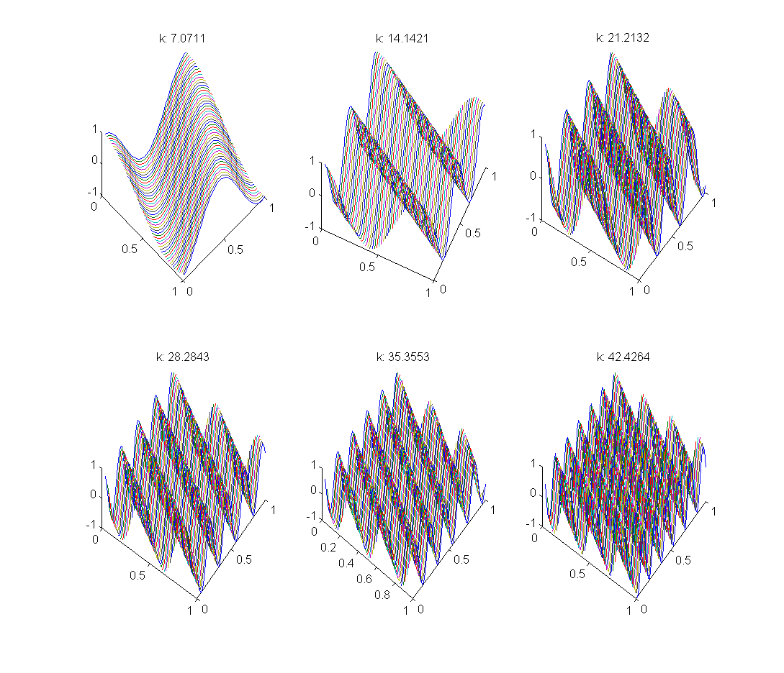

Figure - 2D Helmholtz equation for increasing k

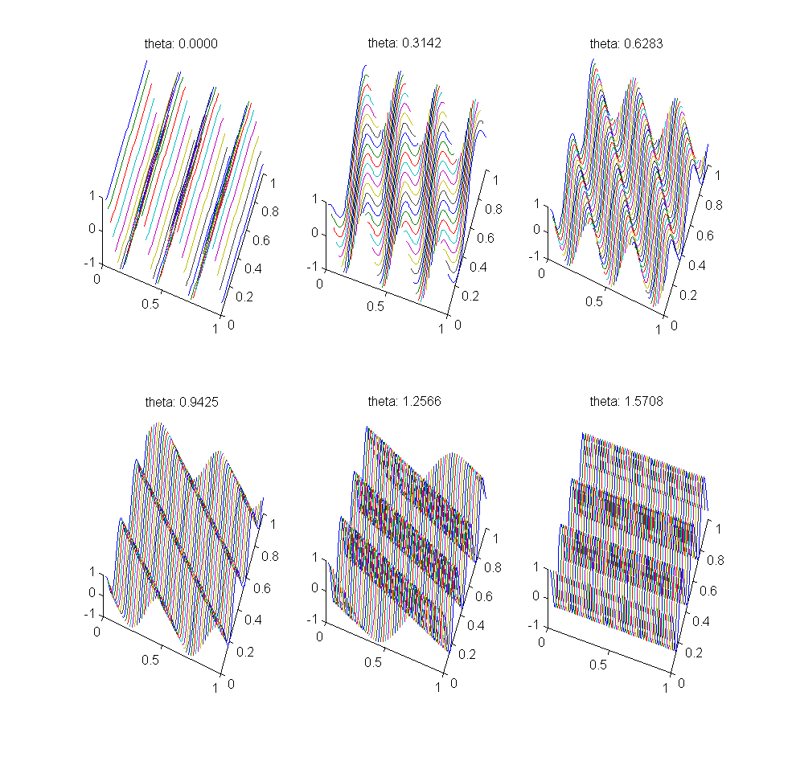

Figure - 2D Helmholtz equation for increasing theta